# Lab 2

**Visual Perception and Cognitive Processes, and a Heuristic Evaluation**

**Exercise 1**

1. **Visual perception - visit the first two links below:**

<http://www.eyecanlearn.com/perception/figure-ground/>

<http://www.eyecanlearn.com/perception/closure/>

What do the visual perception tasks in the above links tell you about yourself and users in general?

1. **Visual perception - Optical Illusions and Visual Phenomena**

Visit this link <http://www.michaelbach.de/ot/> There are 130 illusions and phenomena available. A small sample is listed in the Table below. Explore each of the Illusions and Phenomena listed in the table.

Can our visual perception always be trusted? What are implications for interaction design?

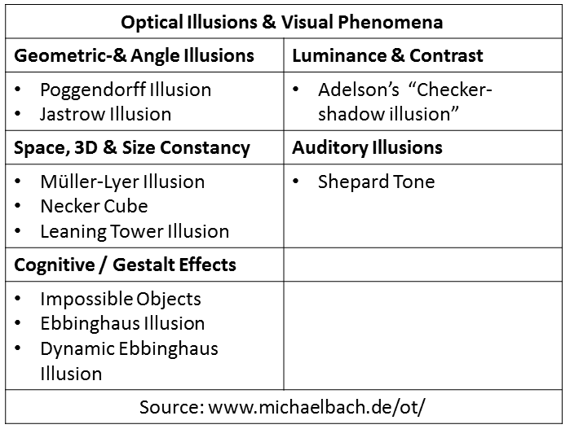

1. **Visual memory**

The Gestalt ‘Laws’ of perceptual organisation were aspects of an early attempt by psychologists to discover ‘laws’ underpinning properties of human visual perception.

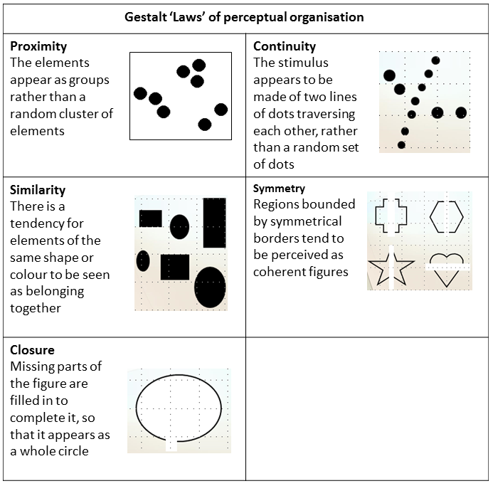

Use the Gestalt ‘Laws’ while playing the following memory pattern game: <http://www.playkidsgames.com/games/patternMemory/patternMemory.htm>

* What does this game tell you about human memory?
* Did awareness of the Gestalt principles help during this game?
* How can knowledge from this exercise help you as an interaction designer?

1. **Testing attention and working memory – do the following activity:**

<http://sharpbrains.com/blog/2006/09/28/attention-and-working-memory/>

* How selective was your attention?
* How is this relevant to HCI and Interaction Design?

**Exercise 2 – Affordances**

The psychological idea of *affordance* suggests that items in the world may suggest by their shape and other characteristics how to interact with them. A button *affords* pushing. You know how to interact with the button by just looking at it. The idea of affordance is powerful tool within interaction design.

1. **What affordances have been created in the design of this camera?**

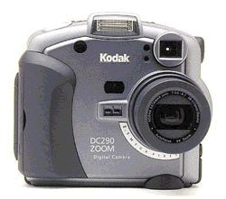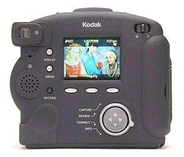

1. **What affordances were used in this User Interface?**

What affordances should have been used?

ETrade

1. **What problems can you see with this old MAC control panel?**

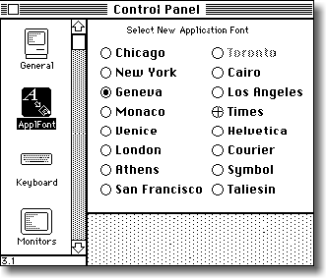

What improvements have been made to the interface below?

What affordances have been added?

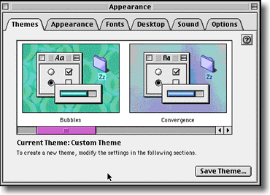

**Exercise 3**

**Heuristic Evaluation of a Website**

Do a Heuristic Evaluation of the DIT Website using Nielsen’s Heuristics.

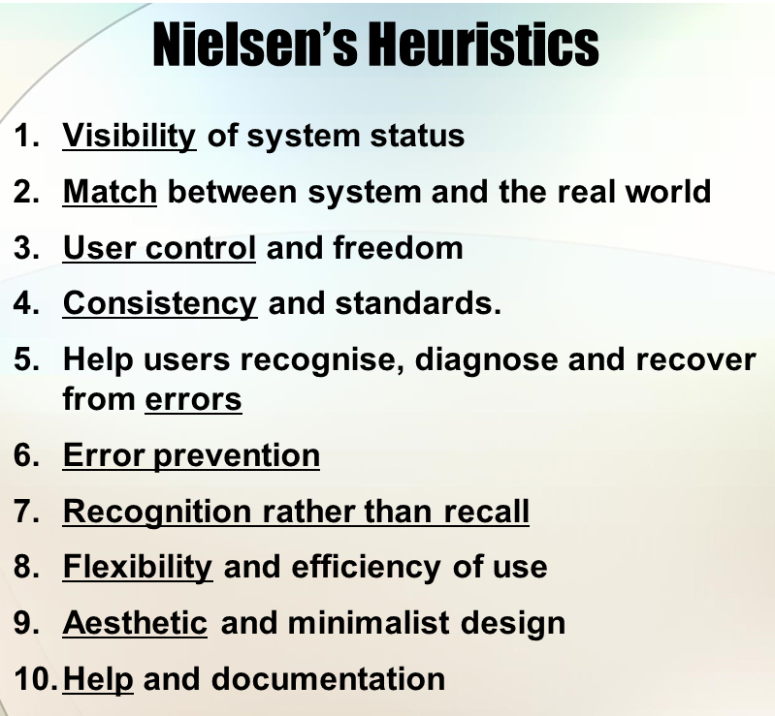

For reference, full details about each Heuristic are available at the Nielsen Norman site here <https://www.nngroup.com/articles/ten-usability-heuristics/>

**Suggested Method:** Treat each of the 10 Heuristics as a question you could ask of the DIT Website to assess the site’s usability. For example. ‘Visibility of System Status’ can be turned into an assessment question as follows:

1. **Visibility of System Status?**

Do you know what is currently happening on the website from the feedback you are getting from looking at the website right now?

From the current ‘feedback’, can you find the link to ACM Digital Library?

Continue with the Heuristic evaluation and ask questions of the DIT Website under the other heuristic headings given above.

Give your answers in bullet point form. Include just one bullet point under each Heuristic.

**Please ensure that you show your completed lab work to the Lecturer or Lab Supervisor before you leave the Lab today.**